**Practical No. 8**

**Aim:** Install & Configure OpenVPN GUI on Windows 10

## ****What is** OpenVPN?**

OpenVPN is a VPN software application, a flexible and stable solution for keeping all your online matters private and secure. OpenVPN-GUI controller helps manage VPN connections. It is popular to depict a VPN as a tunnel, and OpenVPN does not stray far from this comparison. It works on two ends:

* OpenVPN client: an automatic and stable software application usually installed on users’ computers or other devices. It establishes a secure VPN connection. In other words, it is the VPN app itself.
* OpenVPN server: the foundation of the VPN technology, which guarantees secure data transmissions, encryption, authentication, and safe access.

OpenVPN uses either UDP (User Datagram Protocol) or TCP (Transmission Control Protocol) [protocols to build](https://atlasvpn.com/blog/difference-between-tcp-and-udp-protocols" \t "https://atlasvpn.com/blog/_blank) reliable and secure communication between the client and the server. Connections through both of these transport layer protocols are fair game. However, the application chooses UDP as its priority due to its better performance and speed. If UDP is unavailable, then the application will use TCP.

OpenVPN is an [open-source project](https://atlasvpn.com/blog/what-does-free-and-open-source-software-mean" \t "https://atlasvpn.com/blog/_blank), meaning that the community has full access to its code. Thanks to its sophisticated, flexible, and stable built, it is the solid foundation that VPN software applications require. Enthusiasts can produce their [unique offshoots](https://opensource.com/article/18/8/open-source-tools-vpn" \t "https://atlasvpn.com/blog/_blank) and take advantage of the advanced encryption, authentication, and high compatibility.

## ****How to use OpenVPN?****

OpenVPN aces the versatility test. Users can use the software application on various operating systems and devices. From computers running on Linux or Windows to Android or iPhone smartphones – they are all welcome. However, newbies might have wondered: what is OpenVPN GUI? It is a graphical frontend for users on Windows XP/Vista/7/8/10. After you set up the software application, it will build an icon in the icon tab. From there, users can choose their connections and handle all VPN components.

After getting OpenVPN-GUI, control your VPN connection without the need to use command-line prompt or console window. So, you can perform various changes, like viewing the log or changing your password via the OpenVPN GUI.

So, to set up OpenVPN, you need to download the application compatible with your device. Since this is an open-source project, you can use it entirely for free. However, the open-source project requires a decent amount of setting up and configuration.

This necessity to complete long instructions to get the VPN working is not a preference for beginners. They usually prioritize simple and less time-consuming options. While the company offers a pre-configured commercial OpenVPN Access Server, it might not be the tool for an everyday user.

1. **Installation guide for OpenVPN**

* **Steps for installing and configuring open VPN/GUI on windows 10.**

1. **Download the OpenVPN software. OpenVPN is available as a 34-bit and 64 bit version.** 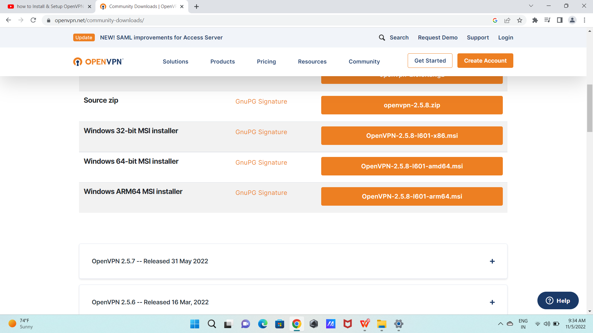
2. Launch the msi installer for openvpn and click next:

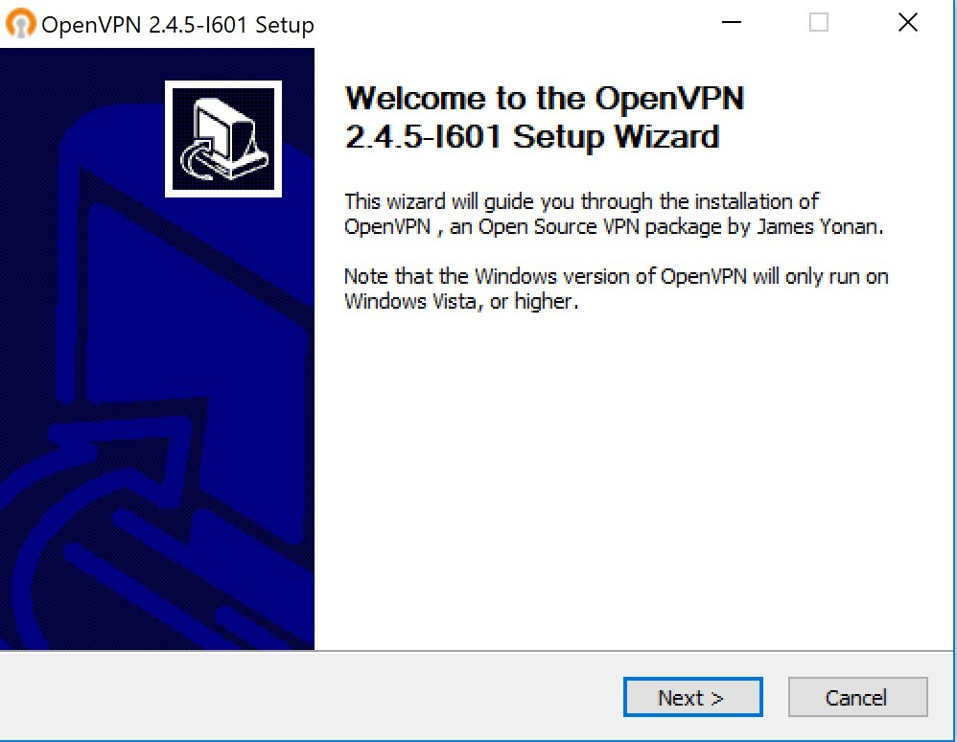

1. Read and click I Agree to indicate your agreement:

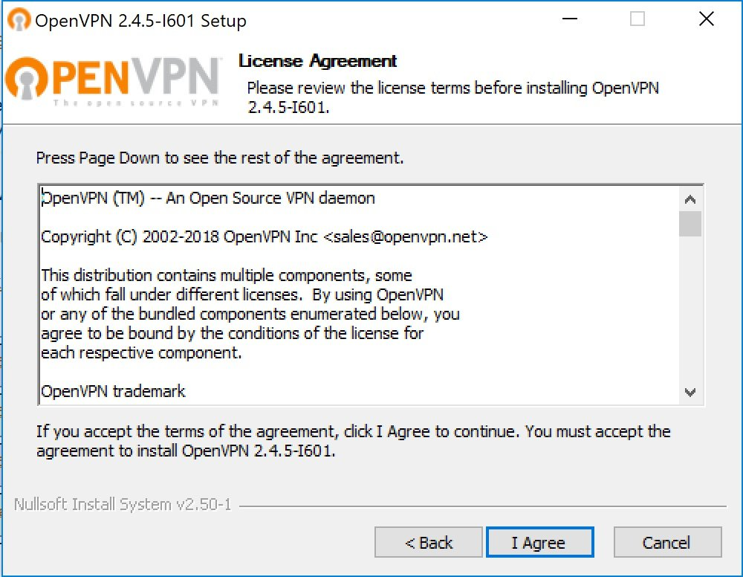

1. Choose the location to install the program files for the Desktop Client and click Install to begin:

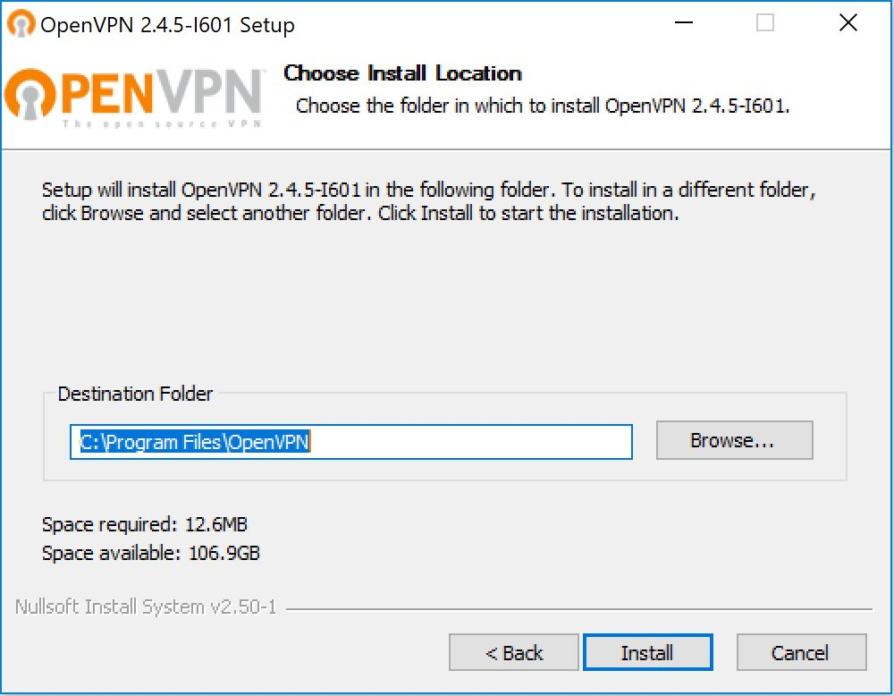

1. You are now ready to install the Desktop Client, ensure TAP Virtual Eth Adapter and OpenVPN GUI are checked:

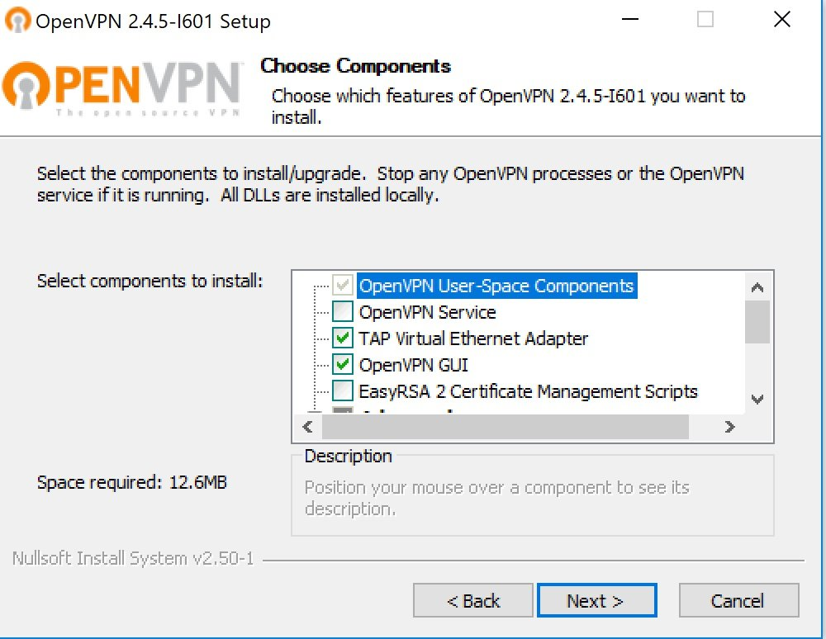

1. Please wait while the Desktop Client Installs, click Next when complete:

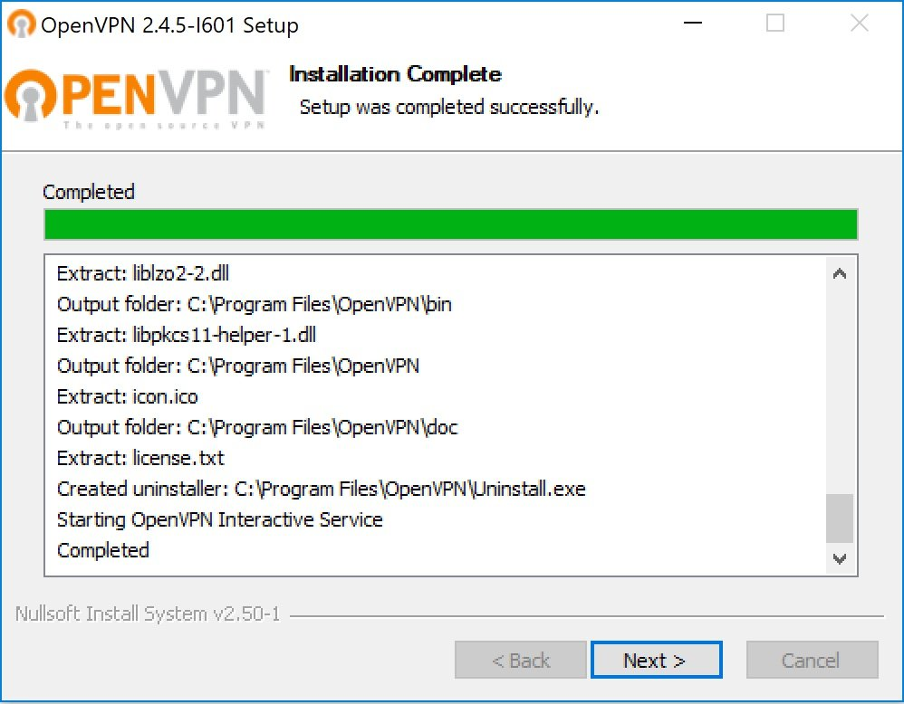

1. You may see a warning asking you to install the Desktop Clients TAP Adapter, check the box that says "Always trust software from "OpenVPN Technologies, Inc." and click Install:

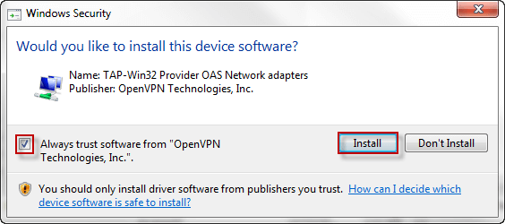

1. The Desktop Client is now installed, click Finish to complete the installation:

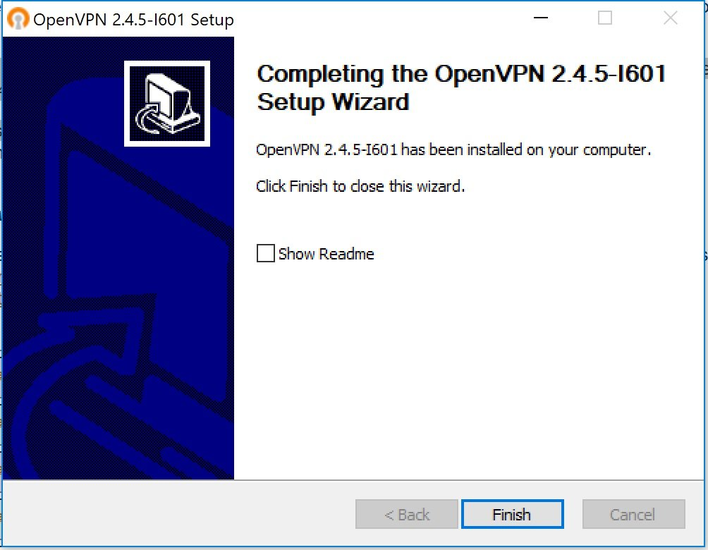

**Conclusion:** Thus we have study the installation of OpenVPN on windows 10.